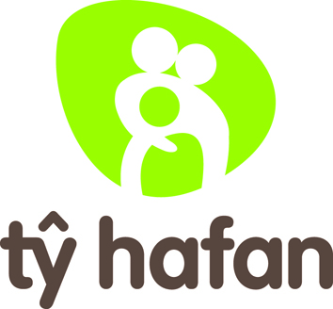

Health and Safety Policy - Statement of Intent

Tŷ Hafan provides free specialist palliative care and support for life limited children and young people in Wales. We are dedicated to improving the quality of life for the families of these children and young people in our care.

- To ultimately prevent injury and ill health, our commitment and intent is to provide safe and healthy working conditions for our colleagues and volunteers and a safe environment for the children in our care and their families as well as for our supporters, visitors, or others who may be affected by our activities.

- The minimal acceptable standard is full compliance with health and safety legislation. Tŷ Hafan is committed to complying with the Health and Safety at Work, etc, Act 1974, The Management of Health and Safety at Work Regulations 1999 and related regulations applicable to the Charity’s activities. We are also committed to achieving the highest levels of health and safety performance through continual, cost effective improvement.

- Health and safety is integral to all of our activities and has equal status with other aspects of performance. Appropriate resources will be provided to implement and continually review and refine our approach to health and safety management.

- We recognise that successful health and safety management can only be achieved with the support and commitment of our employees, all of whom will be actively encouraged to take ownership of health and safety, proactively identifying shortcomings. Colleagues will be engaged in decision making to help minimise hazards and occupational health and safety risks.

- Compliance with Tŷ Hafan’s health and safety policy and health and safety management system are conditions of employment.

- This statement of intent will be displayed throughout all premises in the organisation and we will undertake regular audits to ensure this health and safety policy is adhered to and the related procedures implemented.

- Responsibilities for health and safety are defined in our health and safety management system. Whilst the day-to-day management of health and safety is a responsibility of managers at all levels in the organisation, the overall operational responsibility rests with the chief executive, delegated to the health and safety committee and the head of facilities and estates. The board is ultimately responsible for ensuring compliance with the various and extensive health and safety legislation and regulation governing our operation.

- Tŷ Hafan’s appointed health and safety coordinator supports the implementation of the health and safety management system and administration of the health and safety committee. This committee is held to account by the executive, through regular reporting onward to committees and the board. Supplementary external advice will be obtained where necessary.

- To facilitate continuous improvement in health and safety standards we will identify and regularly review specific health and safety objectives. Progress towards objectives will be closely monitored.

- Periodic auditing of the application of our health and safety policy and the effective implementation of the health and safety management system will be undertaken to ensure their continued adequacy and effectiveness.

- Tŷ Hafan will review this statement of intent on an annual basis and the health and safety policy on a triennial basis.

Signed: ……………………………………………………………… Chief executive

Date:

